*DELIVERY MARKETPLACE*

**Project Summary**

Delivery Marketplace, is a web-based application useful for Customers for handling Delivery Services Effectively. Implemented using ASP.NET and SQL server, this project aims at managing overall Delivery services by handling Customers, Drivers, Products maintenance and movement in addition to details of Customers, Drivers, Payment and Locations.

**Roles**

1. Admin
2. User
3. Driver

**Credentials**

1. Admin
   * admin@gmail.com
   * ***123123***

**Requirement**

* Visual Studio 2019 or above
* SQL Server 2019

**Admin**

* Can Log in to the system to check the Order/Booking details.
* Can Add and manage the products that are listed in the system.
* Can manage the Users that are listed in the system.
* Can manage the Orders that are listed in the system.
* Can manage the Drivers that are listed in the system.
* Can logout from the system once the work is completed.

**User**

* Can Log in to the system to check own Order/Booking details.
* Can Select and purchase the product.
* Can select the pickup and drop locations as per their requirement.
* Can create the feedback on the feedback section effectively.
* Can logout from the system once the work is completed.

**Driver**

* Can Log in to the system to check Order/Booking details.
* Can accept the order that is listed in the Booking list.
* Can select the pickup and drop locations as per their requirement.
* Can create the feedback on the feedback section effectively.
* Can logout from the system once the work is completed.

**Login Page**

User Can Login From This Page.

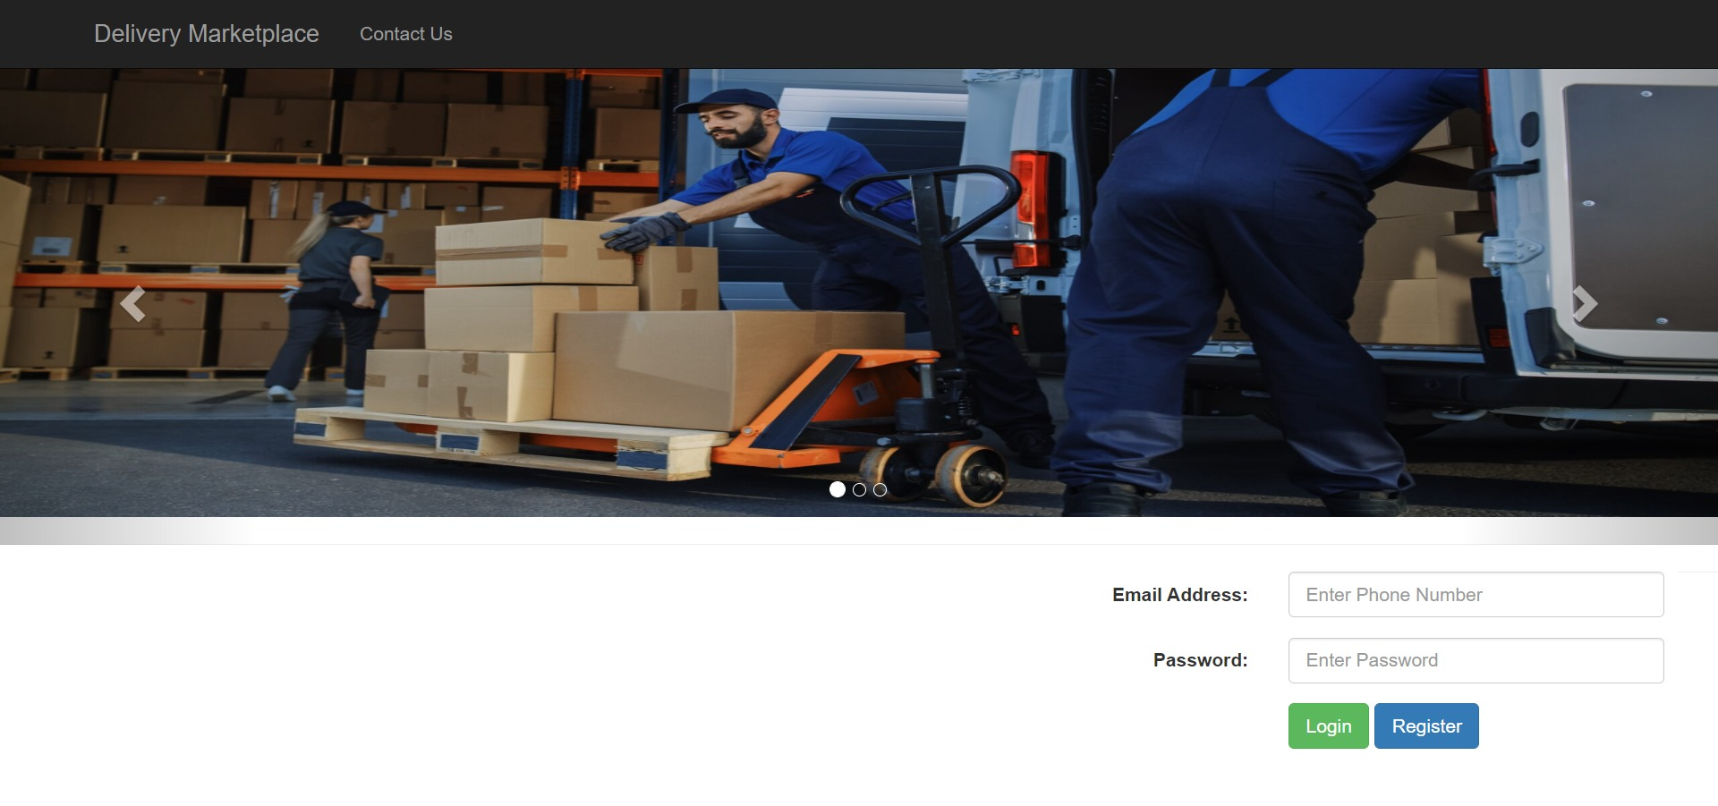

**Register Page**

User Can Register From This Page.

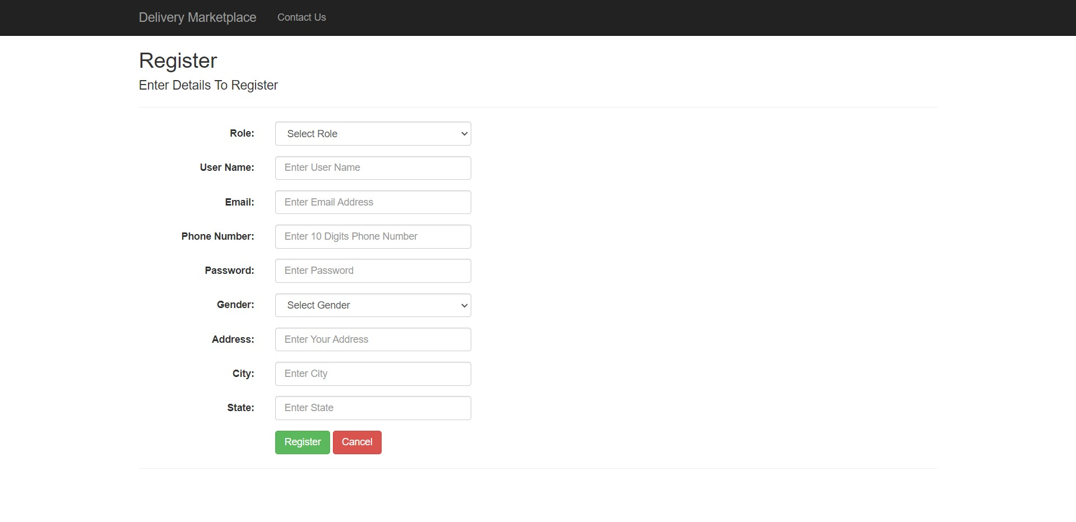

**Modules**

* **Bookings**

1. Bookings List / Index

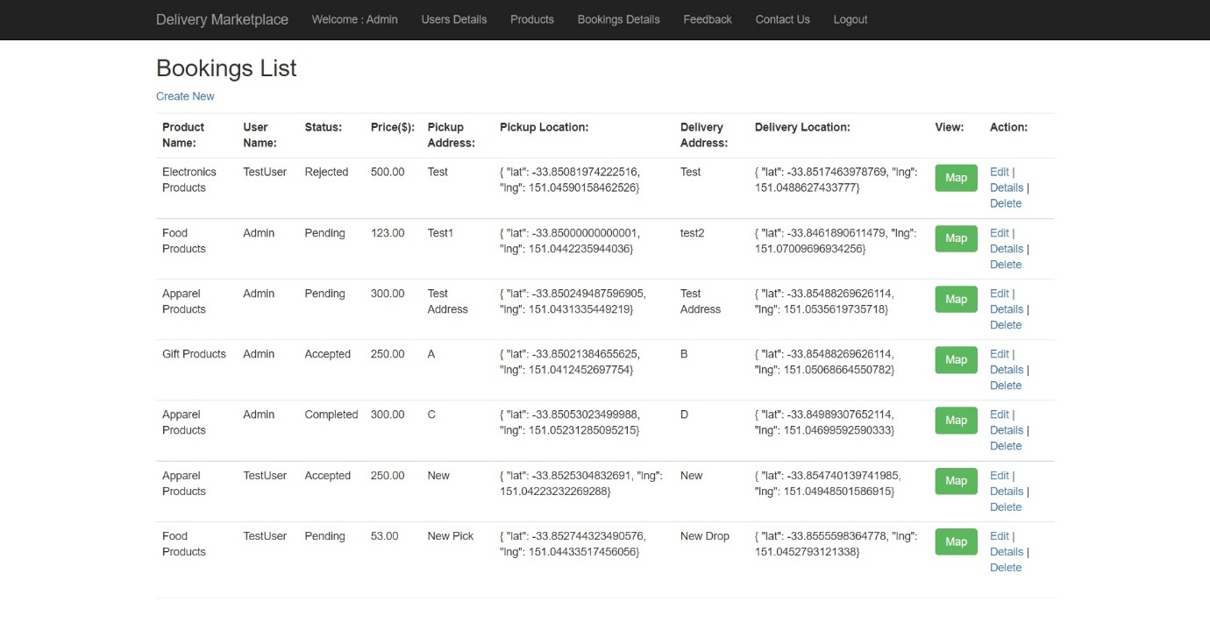

2.Create Booking / Create

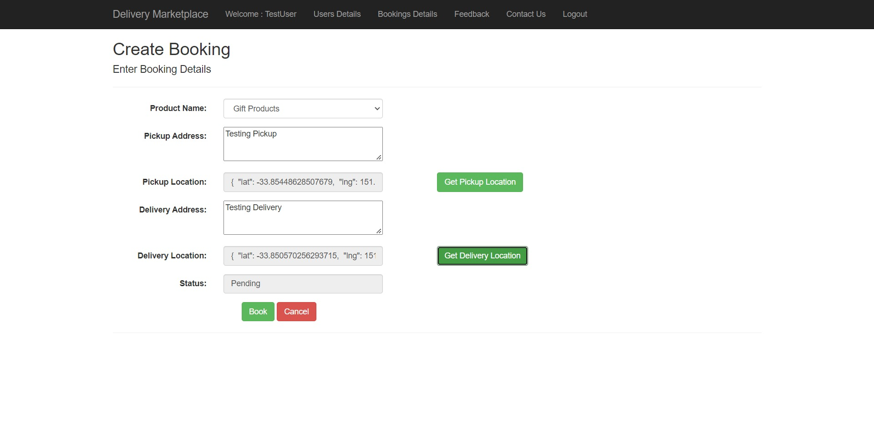

3.Select Pickup/Drop Location

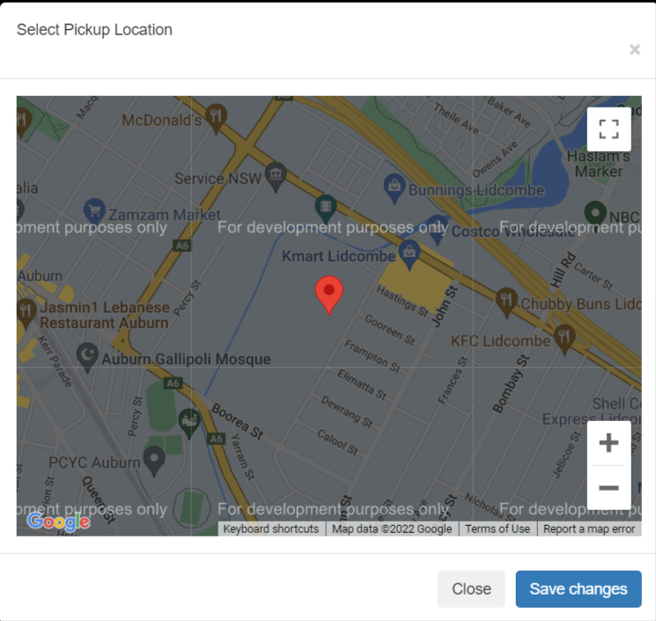

4. Order Confirmation

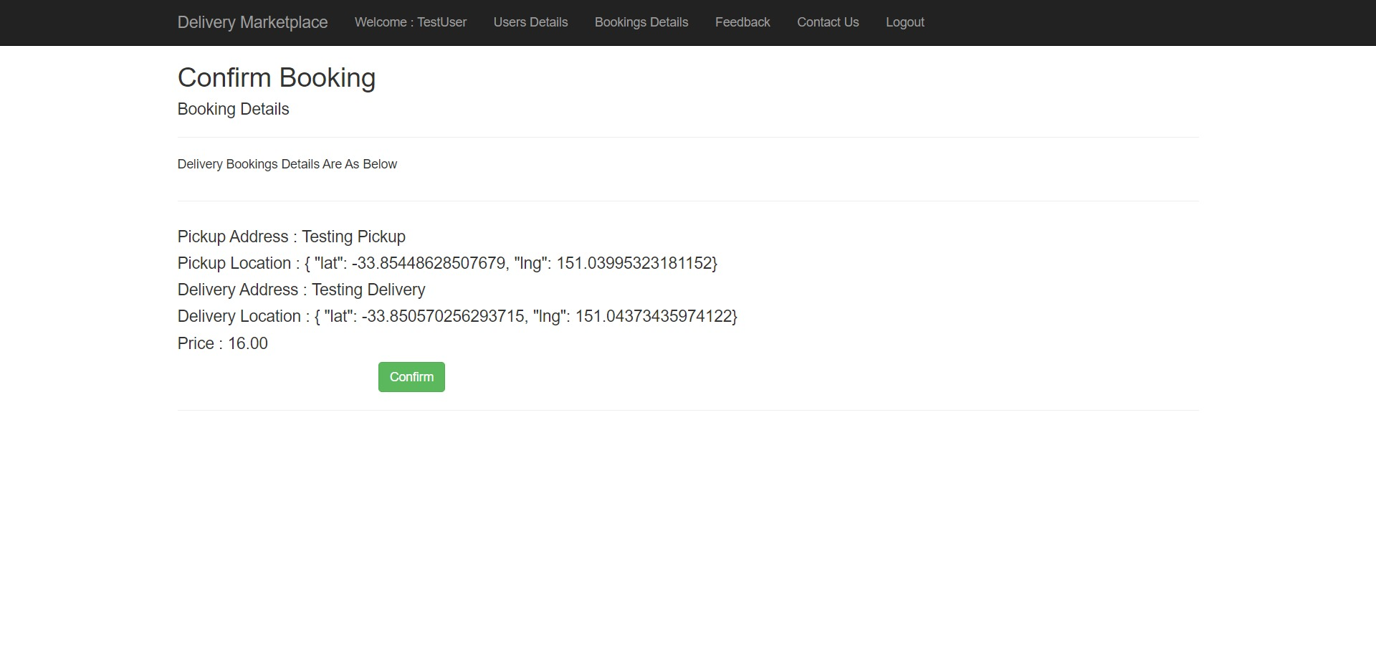5. Order Success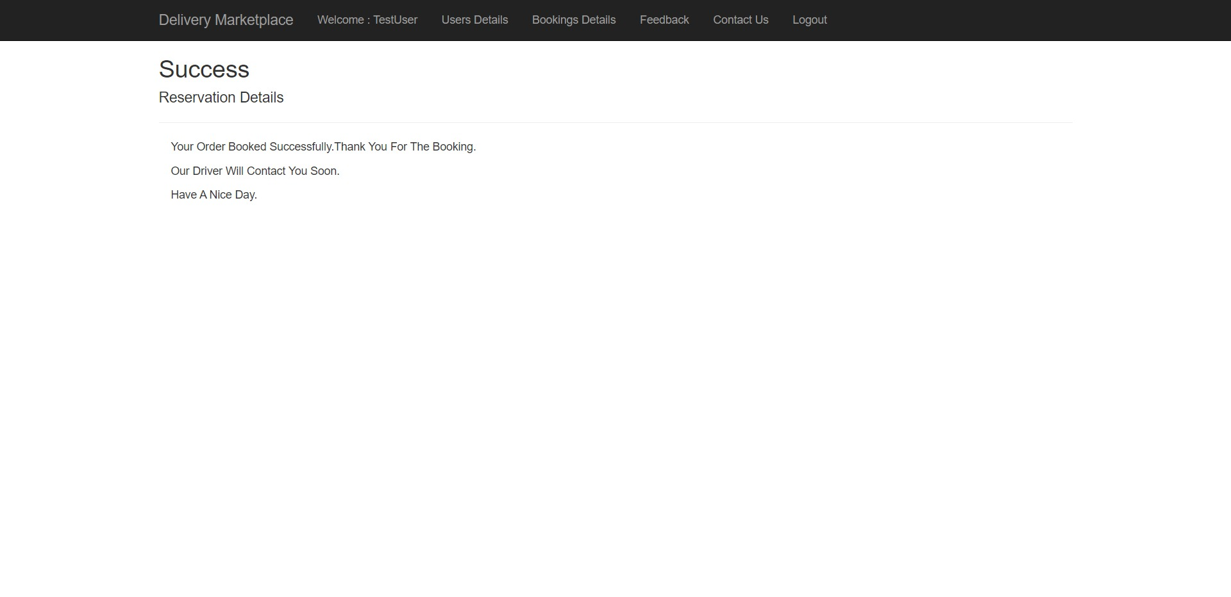

* **Feedbacks**
* Feedbacks List / Index

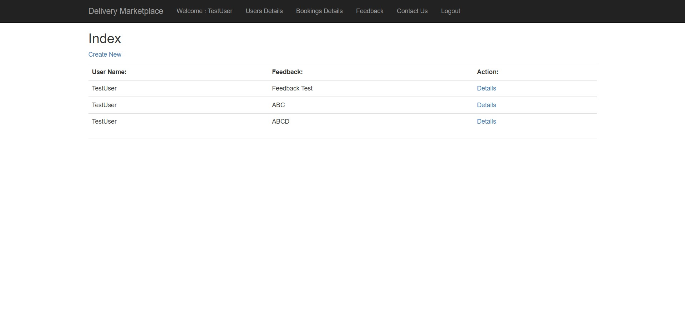

* Feedbacks Create / Create

